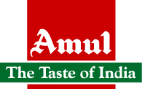

**1.INTRODUCTION**

* Amul means "priceless" in Sanskrit. The brand name "Amul," from the Sanskrit "Amoolya," was suggested by a quality control expert in Anand. Variants, all meaning "priceless", are found in several Indian languages
* Amul products have been in use in millions of homes since 1946
* Amul is an Indian dairy cooperative, based at Anand in the state of Gujarat, (India)The co-operative is also sometimes referred to by the unofficial backronym: Anand Milk Union Limited.
* It was formed in 1946, it is a brand managed by a cooperative body, the Gujarat Co-operative Milk Marketing Federation Ltd. (GCMMF), which today is jointly owned by 3.03 million milk producers in Gujarat.
* Amul spurred India's White Revolution, which made the country the world's largest producer of milk and milk products. In the process Amul became the largest food brand in India and has also ventured into markets overseas.
* Dr Verghese Kurien founder-chairman of the GCMMF for more than 30 years (1973-2006), is credited with the success of Amul.

**2. OBJECTIVE OF THE PROJECT**

* To study the international trade logistics and supply chain practices followed by Amul

**3. SCOPE OF THE PROJECT**

* This report will assist entrepreneurs to follow the best logistics and supply chain practices to improve their productivity and exports.

**4. LIST OF PRODUCTS**

Amul milk

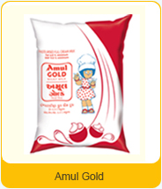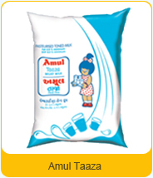

Breadspreads:

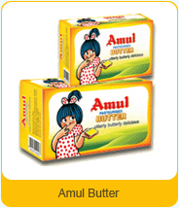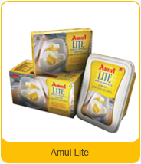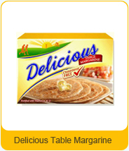

Cheese Range:

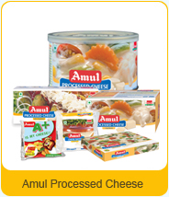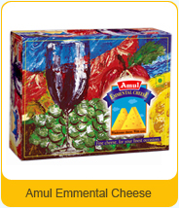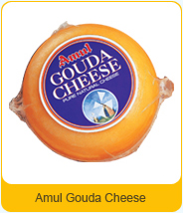

Uht milk

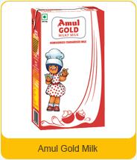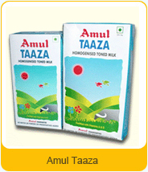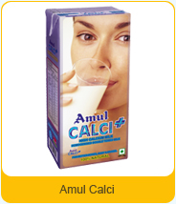

Beverage range

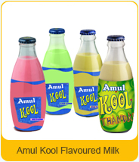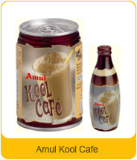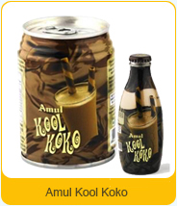

Amul pro

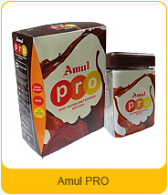

Amul icecream

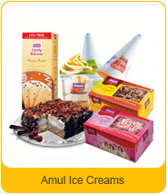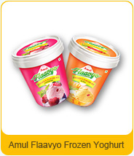

Amul paneer

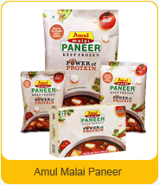

Amul dahi

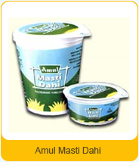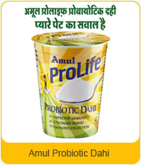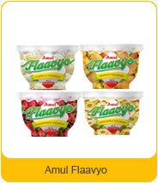

Amul ghee

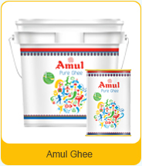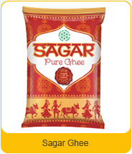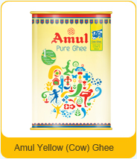

Milk powder

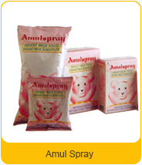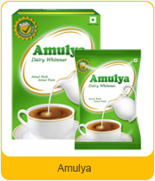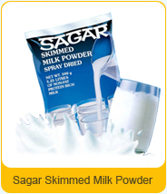

Nutramul

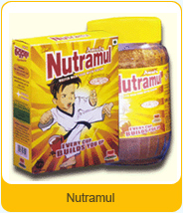

Mithaee Range (Ethnic sweets):

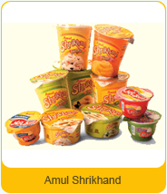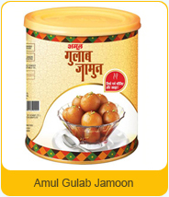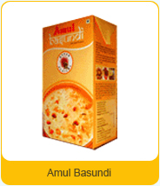

Mithai mate

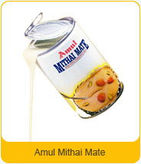

Chocolate

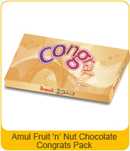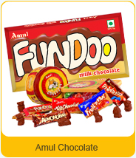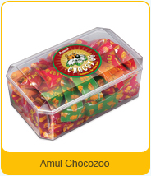

Amul fresh cream Amul butter milk

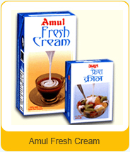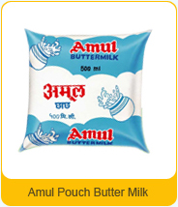

**5. THE AMUL MODEL**

The Amul Model of dairy development is a three-tiered structure with the dairy cooperative societies at the village level federated under a milk union at the district level and a federation of member unions at the state level.

|  |
| --- |
| * Establishment of a direct linkage between milk producers and consumers by eliminating middlemen      * Milk Producers (farmers) control procurement, processing and marketing      * Professional management |

|  |  |
| --- | --- |
|  |  |

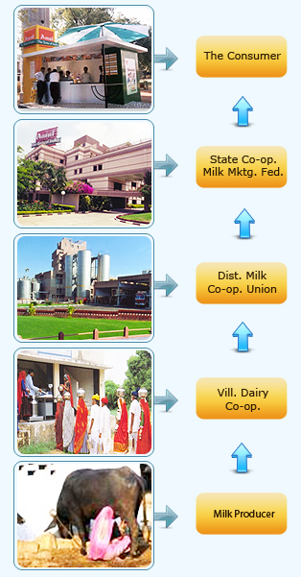

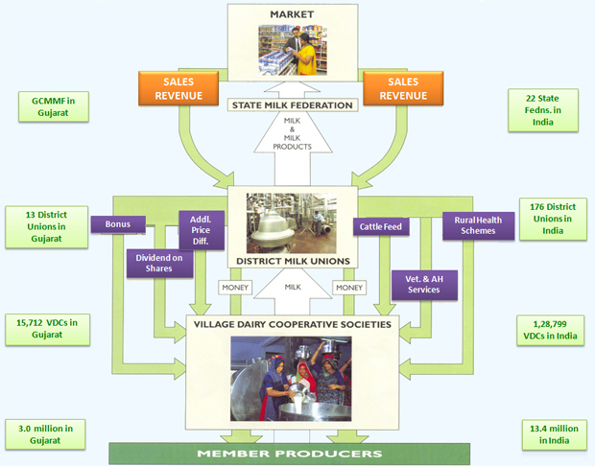

The Amul model has helped India to emerge as the largest milk producer in the world. More than 13 million milk producers pour their milk in 1,28,799 dairy cooperative societies across the country. Their milk is processed in 176 District Co-operative Unions and marketed by 22 State Marketing Federations, ensuring a better life for millions.

**6 . TRADE**

Many of amul products are available in above 40 countries.

Overseas markets

Mauritius,

Uae

Usa

Bangladesh

Australia

China

Singapore

Hongkong & southafrican countries .

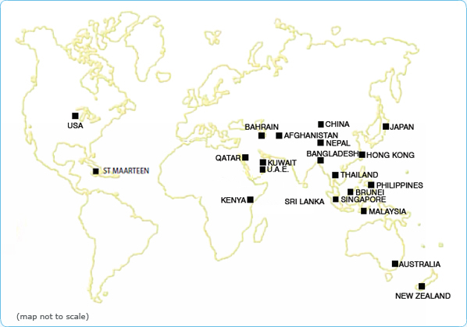

# Amul FY12 turnover up 20% at Rs 11,668 cr

* Amul has crossed the $2.5-billion mark with India’s biggest dairy brand reporting a turnover of Rs 11,668 crore in 2011-12, ended March 31, 2012, out of which Rs 9,901 crore were paid back to 32 lakh farmer members of milk unions.
* Announcing the annual results after the 38th annual general body meeting of Gujarat Cooperative Milk Marketing Federation Ltd, which markets the Amul brand, its Chairman, Mr Parthibhai Bhatol, said on Thursday that the turnover of FY12 was 20 per cent higher than that in 2010-11, Rs 9,775 crore.
* In 2012-12, GCMMF plans to achieve a turnover of Rs 14,400 crore.At a time when farmers in other States were struggling to make their milk business viable in the absence of good returns, their counterparts in Gujarat are rejoicing over a 58 per cent increase in their milk prices over the last three years,
* . Member farmers of GCMMF received a price of Rs 468 per kg of fat for their milk production this year, the highest price being paid to farmers in the country.
* GCMMF initiated its largest distribution expansion exercise to extend its reach to smaller towns and semi-urban areas.
* Apart from the 750 distributors added in dairy and fresh products segment, GCMMF also added 150 super distributors through the implementation of its new ‘hub & spoke’ model, to reach the smaller markets.
* In 2011-12, 965 new Amul Parlours have been added, taking the total strength to 6,315. Apart from the 170 parlours at railway stations and 303 operating at various centres of excellence, Amul also has 600 air-conditioned ice-cream scooping parlours, making it the largest single brand retail in the country.
* GCMMF will be investing Rs 3,000 crore to set up nine processing units in the next four years. “This would enhance our milk handling capacity from the existing 145 lakh litres per day to 180 lakh litres per day.”

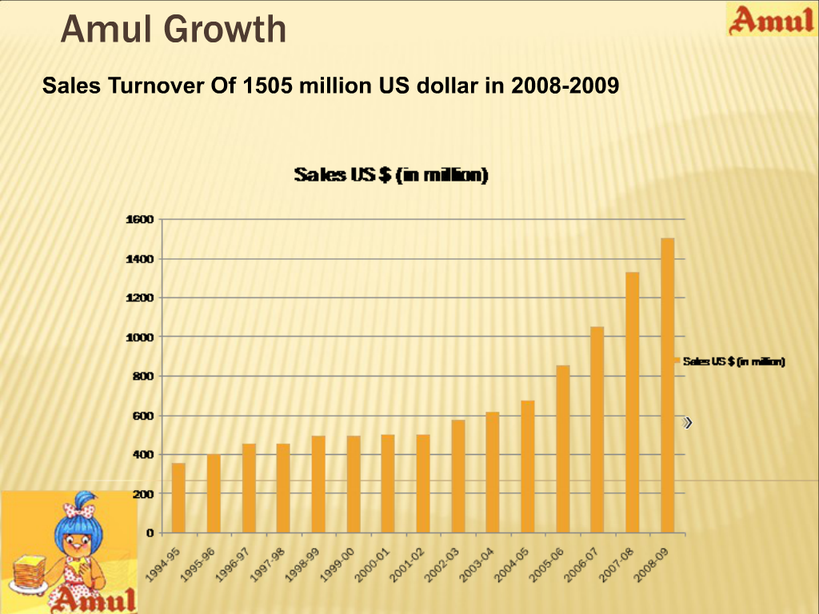

**7. AMUL COMPANY**

* Amul (Anand Milk Union Limited), formed in 1946, is a dairy co-operative in Western India. It is managed by Gujarat Co-operative Milk Marketing Federation Ltd. (GCMMF).
* It is a sterling example of a co-operative organization's success and has been primarily responsible for India to become world’s largest milk producer.
* It has established itself as a uniquely appropriate model for rural development and spurred the White Revolution of India.
* The company is owned by 3.1 million proud Indian farmers and caters to almost 2.1 billion consumers.
* Few companies have gone the distance in connecting the farmer with the consumer in a seamless chain as Amul did. Their basic philosophy has been ensuring maximum returns to the milk producer and makes “Value for money” milk products for its consumers.

**VISION:**

* **Liberate the farmers from economic oppression and lead them to prosperity.**
* To implement this vision, a hierarchal network of co-operatives was developed which forms the backbone of the strong Amul’s Supply chain and stretches from small farmers to most fragmented markets. Amul developed distinct capabilities that would deliver competitive advantage to its operations and leveraging on scarce resources. But the fact is that GCMMF is directly responsible only for a small part of the supply chain and a number of third party players are involved, such as milk collection, distribution of dairy products, logistics etc. Managing this supply chain is critical for Amul’s competitive position considering the low margin business.

**PRODUCT PORTFOLIO :**

* Amul has got a diverse portfolio and thus follows umbrella branding strategy through this vast network. The range of products is similar in production by the various unions it handles. Thus with umbrella branding, Amul avoided inter-union conflicts and increased co-operation in developing products.

**SWOT ANALYSIS**

**Strengths**

* Reputation of being the largest food brand in India
* Provides high quality varied product range at low/affordable price
* Grading and packaging of all its products meets international standards
* Robust distribution network: Amul products are available in over 500,000 retail outlets across India through its network of over 3,500 distributors
* It holds high confidence and loyalty in the minds of the customers since it manufactures only milk and milk products which is purely vegetarian
* Owing to heavy brand recall from milk and butter products, it can easily promote selling of chocolates without fearing of losses and decreasing revenue

**Weakness**:

* Potential high risk due to complex supply chain and weak infrastructure
* Unorganized third party sector which can make the whole supply chain vulnerable
* Capital investment is comparatively low
* Demand supply mismatch as there is no control on the milk yield

**Opportunities:**

* Rural segment, which covers a large area of its loyal and prospective customers.
* Expand in other portfolios such as ice cream, processed foods, chocolates etc.
* Can promote tie-ups with various food chains

**Threats**:

* Brand loyalty may take a hit in the ice cream and chocolates business, due to changing tastes and preferences
* Threat of competitors who hold majority shares in market in other products
* Potential threats from the unorganized sector for the milk vendors
* Growing prices of milk and milk products

**8. SUPPLY CHAIN OF AMUL**

**The distribution network**

* Amul products are available in over 500,000 retail outlets across India through its network of 3,500 distributors. There are 47 depots with dry and cold warehouses to buffer inventory of the entire range of products.
* GCMMF transacts on an advance demand draft basis from its wholesale dealers instead of the cheque system adopted by other FMCG companies. This practice is consistent with GCMMF’s philosophy of maintaining cash transactions throughout the supply chain and it also minimizes dumping.
* Wholesale dealers carry inventory that is just adequate to take care of the transit time from the branch warehouse to their premises. This just in time inventory strategy improves dealer’s ROI. All the branches of GCMMF are engaged in route scheduling and have dedicated vehicle operations.

**Largest Cold Chain:**

* AMUL has the largest cold chain network in India (18000 refrigerators) as compared to any other company. The chemical components of milk are water, SNF and solids. It is a perishable product so it has to be consumed within 24 hours. In order to avoid wastage AMUL converts the milk into SNF (Solids not fats) and milk solids by evaporating the water, which comprises of 60-70% of the milk contents.

**Customers*:***

* India is still in the evolutionary stage with tremendous potential for high value products such as variants of milk. The distribution network is quite reasonable with access to metros as well as rural areas.

**Suppliers*:***

* A majority of suppliers are small or marginal farmers who are illiterate, poor and with liquidity problems.

**Third party logistics service*:***

* There are ample deficiencies in the current infrastructure and the outbound logistics is taken care by GCMMF coordinating with distributors. It also connects with unions for product mix, product allocations and in developing production plans.
* The key lies in matching supply and demand as the demand outstrips supply by a big margin.

**Interlocking control*:***

* The objective of interlocking mechanism is to ensure that the interest of the farmer is always kept at the top of the agenda through representatives who constitute the Boards of different entities that compromise the supply chain. Professional managers and farmers work together as a team to strengthen the cooperative.

**Coordination agency:**

* Objective of such an agency is to ensure the milk produced by the farmer is sold in the market either as milk or as value added product.



### Village Dairy Cooperative Society

### Collection of surplus milk & payment based on quality & quantity.

### Providing support services to the members.

### Selling liquid milk for local consumers of the village.

### Supplying milk to the District Milk Union

**Member Unions or Depots**

* Procurement of milk from the VDCS
* Providing input services to the producers.
* Conducting training on Cooperative development
* Providing management support & regular supervision to the VDCS.
* Establish Chilling Centers & Dairy Plants for processing the milk.
* Selling liquid milk & milk products within the District.
* Process milk into various milk & milk products.
* Decide on the prices of milk to be paid to   
  milk producers.

**Corporate Office Functions**

* Marketing of milk & milk products
* Establish distribution network
* Arranging transportation from the Milk Unions to the market.
* Creating & maintaining a brand
* Providing Technical Inputs, management support & advisory services.
* Decide on the products to be manufactured at various Milk Unions (product-mix)
* Conduct long-term Milk Production, Procurement, Processing & Marketing Planning,Conflict Resolution & keeping the entire structure intact

**Procurement Network**

* An average of 1,000 Farmers sell milk at a Local Cooperative society.
* Each Farmer has plastic cards for identification.
* The Identification Number is fed into a computer.
* The milk is then weighed and the fat content of the milk is measured by an electronic fat testing machine.
* The Computer then calculates the amount due to a farmer on the basis of the fat content in the milk.
* The value of the milk is then printed out on a slip and handed over to farmer who collects the payment at adjacent window.

**Policies**

* Regarding Rural market: No different policy for Rural Market.
* Differential Prices: Most of the Amul product has lower prices in state of Gujarat due to less transportation cost.
* Unused Milk: Milk, once, supplied to retailer is not taken back. Retailer uses the unused milk after “Best before” date for making other dairy products such as Paneer, etc.

**Distribution and Dealers**

**Distribution Channel** – From the manufacturing units to the retailers.

* Amul products are available in over 800,000 retail outlets across India through its network of over 5,000 distributors.
* First Leg – From manufacturing units to Depots: Amul has 65 depots across major cities of India.
* Second Leg – From Depot to Wholesale Dealers: Amul has a network of over 5000 distributors . The margins offered to the distributors range between 3-5%.On every crate there is a margin of Rs 5.5 .No volume discounts to distributors, prices are fixed.
* Third Leg - This is the flow of good from WD’s to retailers, a beat plan is prepared and transportation is done on auto-rickshaws, rickshaws and bicycles.

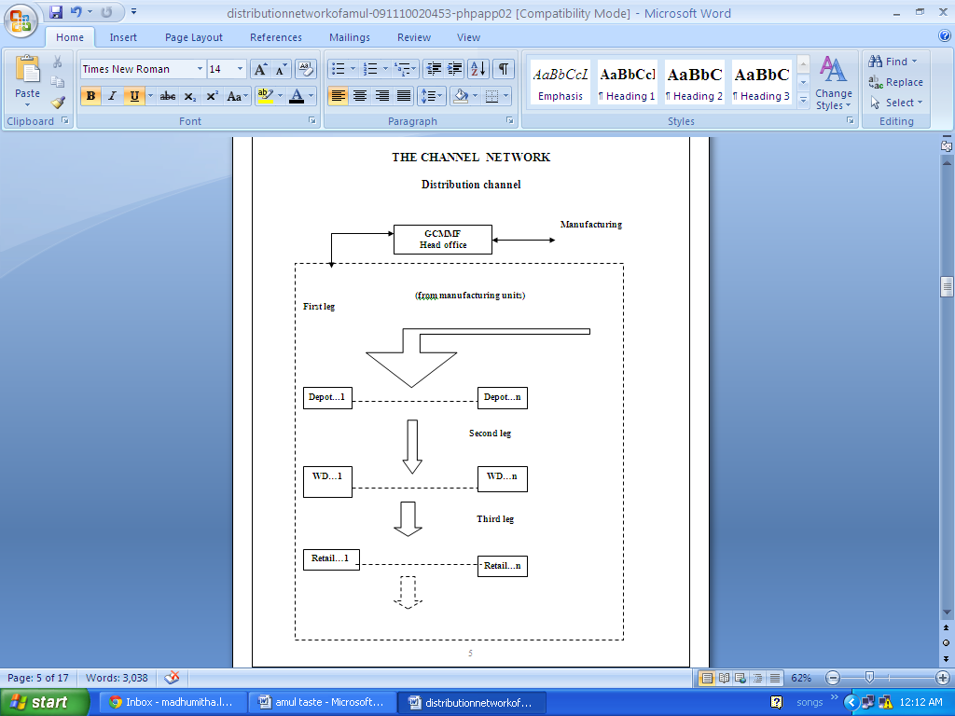

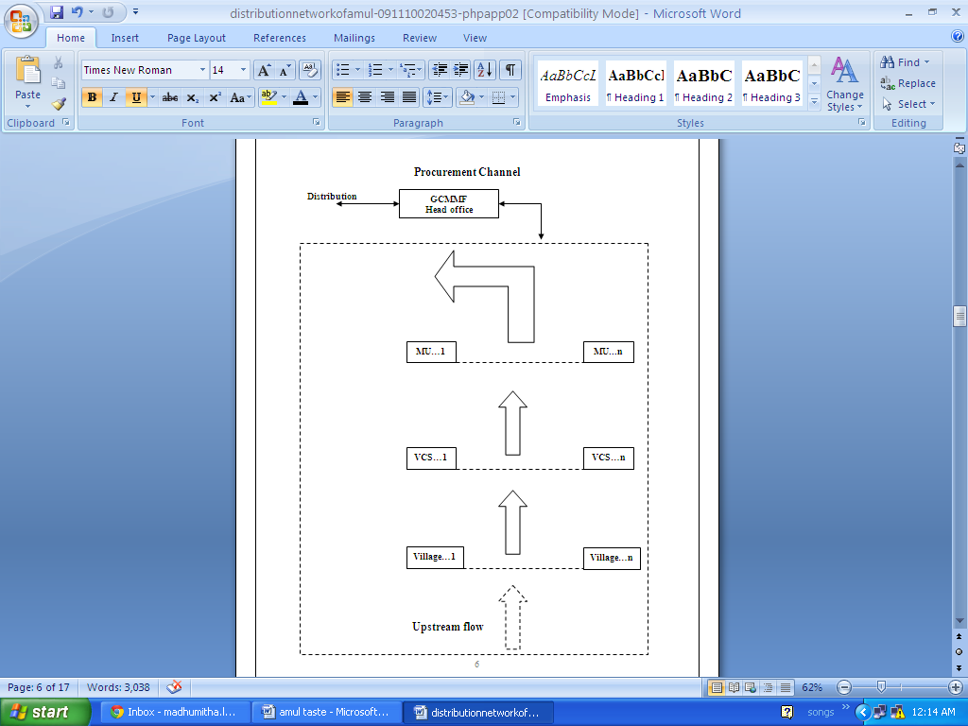



**9.MARKET LOGISTICS**

**The network**

* Milk is procured from the villages and collected at Village Cooperative Societies (VCS); from there the milk is taken to manufacturing units where the milk is processed into various products.
* The products are then transporters to the company Depots located in various parts of the country.
* The products are then sent to Wholesale Distributors (WD) and from there to the retailers.

**The fact sheet**

* Milk is procured twice a day from 2 million from Gujarat alone
* The payment is made under twelve hours of procurement
* There are 10000 village cooperative societies
* There are 3600 wholesale distributors in the country
* 45 depots
* The C&F agents are not fixed and are decided by the local company offices
* There are approximately 4,50,000 retailers spread all over India
* Total house hold consumers covered are 100,000
* The milk procured per day is 5 million liters
* Where the total capacity of operation is 7 million liters per day
* The peak processing till date has been 6 million liters per day
* These co operative societies are bound to supply there produce only to GCMMF.

**Enterprise resource planning:**

* The company at has implemented an ERP program as low as Rs. 3 corers in collaboration with TCS ltd. The company uses it; the data right from the procurement from the farmers till the delivery of goods to the retailers is fed into the system.
* The software enabling the channel members to use for the synchronized working and best possible utilization of the available resources maintains details regarding the inventory management. Market logistics deals with the implementation of the SCM of the company.

**Upstream Channel (farmers to the manufacturing units.)**

.

* In the first step, the milk is taken to the VCS by the farmers on foot or bicycles in small quantities
* The second step involves the transportation of milk from the co-operatives to the manufacturing units this is done in special trucks which are equipped with tankers to carry milk.

**Downstream Channel ( manufacturing units to the retailers).**

1.**First leg of transport is from the manufacturing unit to the company depots**.

* This is done using 9 and 18 MT trucks any lesser quantity will be uneconomical to the company there fore is some time the quantity ordered is lesser then club loading is done which means that the product ordered is supplied with some other products.
  + Frozen food the temperature of these trucks is kept below -18˚C
  + Dairy wet the temperature of these trucks is kept between 0-4˚C

**2.Second leg is from the depot to the WD’s,**

* this transport is carried out in insulated 3 and 5 MT TATA 407’s here a permanent dispatch plan (PDP) is prepared where the distributor plans out the quantity of various products to be ordered on a particular date.

3.**Third leg this is the flow of good from WD’s to retailers**,

* transportation is done on auto-rickshaws, rickshaws and bicycles.

**CONCLUSION**

* All the entrepreneurs who want to excel in dairy industry and get high profits and revenues need to follow the different strategies which are formed by amul .
* some of them are mentioned below
* The company’s strength is in its procurement network. Amul has loyal cooperatives that provide milk with the relationship of trust
* Transport channel is another , strength as the transporters have grown with the company overtime the bonding with them enables the company to give least margins when it comes to the distributors in the industry, lowering the costs.
* The company believes that there is an ongoing demand in the market and therefore no promotions are needed to increase the sales, also the fact this would affect the cost of the product the company doesn’t undertake many promotion schemes.
* The not being a profit driven organization, is able to provide products at the least price in the industry, and is able to give least channel margins as the channel members earn through volumes and not through high margins

**BIBILIOGRAPHY**

www.amul.com

http://www.iimb.ernet.in/

http://www.fsg.org/Portals/0/Uploads/Documents/PDF/India_CSV_Appendices.pdf?cpgn=WP%20D L%20-%20India%20CSV%20Appendices

http://www.youtube.com/watch?v=N_950sc6oZk&feature=relmfu

http://www.rediff.com/money/2005/sep/23spec.htm

http://en.wikipedia.org/wiki/Amul

http://www.moneycontrol.com/news/wire-news/dairy-farmers-will-suffer-if-fdi-is-allowedretail-gcmmf_645521.html

http://www.financialexpress.com/news/amul-claims-to-be-no-1-in-delhi-mother-dairy-refutes-it/580518/1

http://www.business-standard.com/india/news/amul-milk-to-get-costlier-by-5-7-soon/469844/

http://www.financialexpress.com/news/amul-gears-up-to-strengthen-fresh-milk-base-in-delhi/86054/2